Database System Engineering and Distributed Backend Development
Course Code: 25CS1302E
Example 3
Name: M. Keerthi Sri
Roll no: 2520030079

CREATE DATABASE
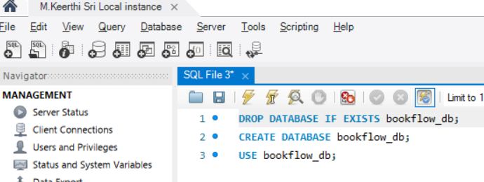
OUTPUT:
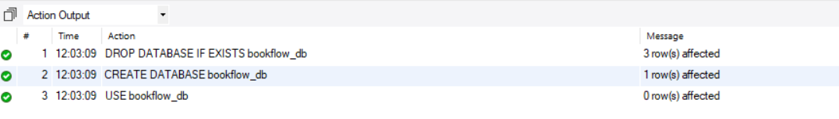

CREATE BOOKS TABLE
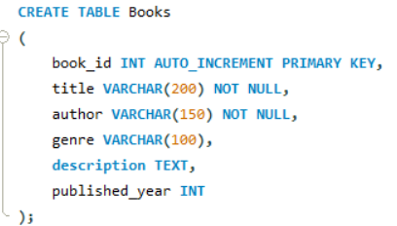
OUTPUT:

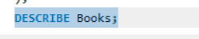

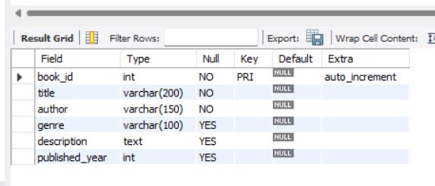

INSERT BOOK DATA

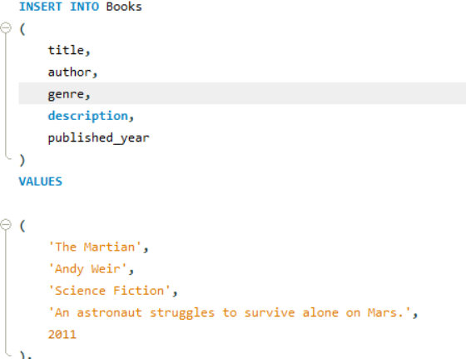

DISPLAY BOOKS
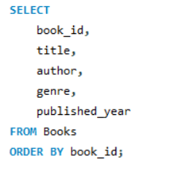
OUTPUT
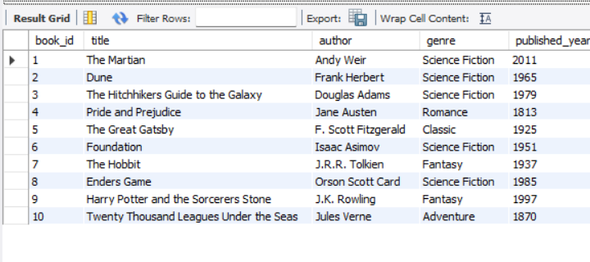

ADD EMBEDDING COLUMN
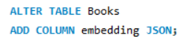
OUTPUT


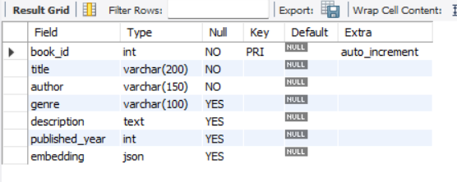

INSERT MOCK VECTORS
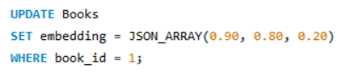
OUTPUT

DUNE
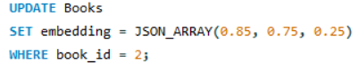
OUPTUT

HITCHHIKERS GUIDE
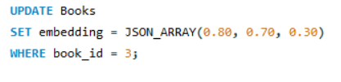
OUTPUT

PRIDE AND PREJUDICE
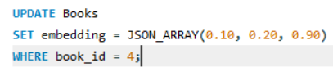
OUTPUT

GREAT GATSBY
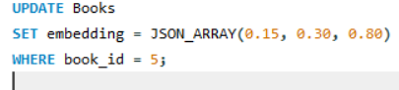
OUTPUT

FOUNDATION
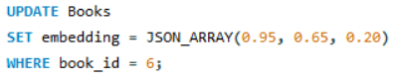
OUTPUT

THE HOBBIT
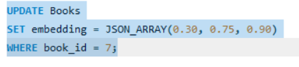
OUTPUT

ENDERS GAME
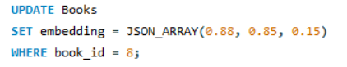
OUTPUT

HARRY POTTER
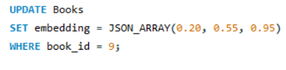
OUTPUT

TWENTY THOUSAND LEAGUES
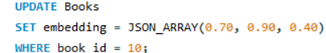
OUTPUT

VERIFY ALL VECTORS
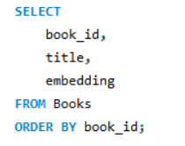

OUTPUT
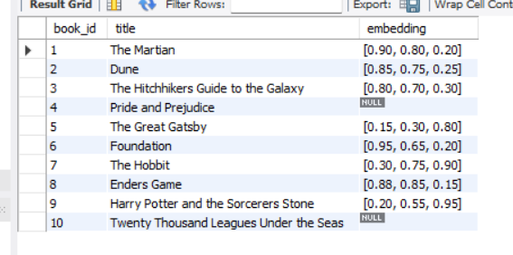

SEARCH VECTOR
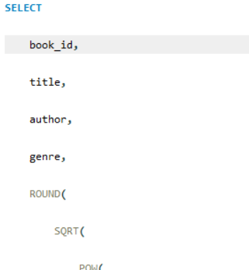
OUTPUT
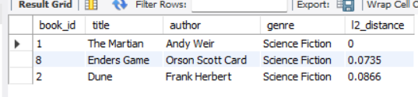

COSINE SIMILARITY
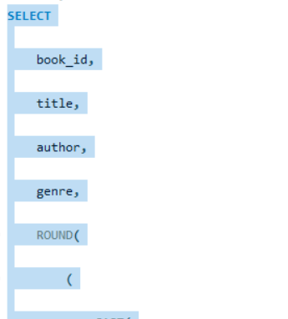
OUTPUT:
